The inherent bias in studies reporting outcomes using total opioid burden metrics: a simulation study
Dylan Whitaker
Matthew Wilson
Steve Harris
Table of contents

Cover Letter
Professor Hugh Hemmings,
Weill Cornell Medical College,
New York,
NY,
USA
Dear Professor Hemmings,
We thank you for considering our Research Communication manuscript titled “The inherent bias in studies reporting outcomes using total opioid burden metrics: a simulation study” to the British Journal of Anaesthesia.
Our paper is a methodological critique of total opioid burden metrics (such as oral morphine equivalent) that finds an important measurement bias. The bias is present in any study comparing groups with unmatched mean opioid doses opioid or where there is an error in the conversion values used with regards to the biological ground truth. The measurement bias can skew or even invert the observed treatment association depending on the specific circumstances of the study. We conclude that any study using total opioid burden metrics should asses the degree of bias in the context of their minimum clinically important difference to ensure the results can be interpreted accurately. Whilst this applies predominantly to observational research, there are key implications for randomised controlled trials with regards to analgesia protocols.
Despite multiple attempts to unify the methodology with conversion tables and calculator tools, the inherent bias continues to be overlooked. Given over 4,000 published papers have used total opioid burden metrics in the last decade, and it remains an important quantitative outcome measure for perioperative pain research, the potential implications of this bias are significant .
We hope this paper will lead to a critical review of how total opioid burden metrics are used in research and improve the accuracy in the metrics already widely used.
We can confirm no parts of this work have been presented before and has not been under consideration at any other journal.
Many thanks, The authors

1. Manuscript

1.1 Introduction
There is a wide variety of opioids used across the range of clinical specialities and patient groups, each with their own potency to provide analgesia¹. Opioid conversion values offer the ability to convert a specific opioid into the equivalent units of a reference opioid, to produce equi-analgesic doses measured in oral morphine equivalent (OME) or milligram morphine equivalent (MME) depending on the reference. This is commonly conducted to enable comparisons within research studies (as an outcome measure) or clinically to guide opioid switching.
We define the total opioid burden (TOB) as the generalisation of the reference-specific metrics OME and MME, estimating the summed analgesic exposure through opioid medications to a patient. Formalised, TOB is the weighted sum of the dose $d$ for medication $i$ in the set of medications $M$ multiplied by the conversion value $c$ for a given route $r$ (Equation 1.1).
TOB=i∈M​dici,r (1.1)
A number of conversion value tables have been published aiming to provide a “best estimate” of the conversion values between opioids^{2–4}. Within clinical practice, these cited value tables are conventionally treated as a good surrogate for the true conversion value⁵. However, these values have been co-opted to produce metrics used in research without additional methodological quality assurance. A commonly used, and often primary, outcome in perioperative analgesic studies is the difference in opioid requirement between groups, as measured by comparing the arithmetic mean of summed TOB.
There is an implicit claim that once converted, it no longer matters which opioids a patient receives. However as demonstrated by the STRATOS guidance, misspecified weights with differential exposure leads to measurement error⁶. The mathematical proof in Supplementary material A demonstrates that this is true if either following conditions are satisfied (Equation A.14):
- There is no error in any of the conversion values used
- The mean dose of all medication between groups are equal
If one of the possible conditions is not satisfied exactly, a measurement bias arises that can skew or even invert the results of a study. In this simulation study we aim to quantify the extent of this bias and to estimate the impact on the current body of literature.

1.2 Methods
Two simulation studies were performed to understand the extent and impact of the bias on studies comparing group mean differences in TOB (Supplementary material B). The first simulation explores the parameter space between groups with inversely distributed opioid groups and conversion values with errors of $±$ 100% of a “ground truth” value. The second, simulates a hypothetical study of 180 participants to analyse the effect of robotic surgery on pain, using an “exogenous shock” to vary the inter-group opioid proportions and varying conversion values to vary the degree of the measurement error. The outcome in both simulations was the degree of bias, estimated by measuring the observed difference compared to the expected difference in group mean TOB.
To assess the current practices of TOB methodology and reporting in perioperative research a exploratory literature search was performed (Supplementary material C). After screening, data was extracted from a random subset of 20% of the eligible studies. For manuscripts that reported the group mean doses of each opioid, recalculation of point estimate and dose range was attempted using a range of conversion values. A literature search protocol was then formalised (Supplementary material D) and registered on the Open Science Framework.
No ethical approvals were required for this study. All simulations were performed in R version 4.6.1 (2026-06-24) and code is available on Github. Methods are reported with the relevant guideline^{7, 8}.

1.3 Results
The first simulation illustrates Equation A.14, if either condition is met the observed difference is equal to the expected difference and there is no bias. The bias that arises from either a difference in opioid proportions (with no treatment effect) or conversion value error combine with a bilinear relationship to diverge the true and observed associations.
The second simulation shows that this bias is clinically relevant under the realistic conditions of the hypothetical study. A true treatment association of -10% (-5 TOB mg) with a $ϵ_{\text{oxycodone}}$ of -14% is observed to have a bias of -24% (1.179 TOB mg). However under a range of experimental conditions, the measurement bias can vary between 263% (-13.15) and -159% (7.95) of the true associational effect, potentially inverting the study results.
The exploratory review included 83, of which 27 (33%) stated the conversion values used while 8 (10%) reported the proportion of opioids between groups. Of those, only 5 studies provided the within group mean opioid doses to allow the calculation of the outcome metrics independently.
Figure 1.1 shows the study reported outcome alongside the calculated outcome for each of the 5 studies reporting mean doses. This demonstrates the difficulty replicating metrics due to the number of calculation assumptions. In studies with single opioids (Fedorka 2025⁹) the bias is minimal, however in studies investigating different analgesic treatments (Carter 2025¹⁰) a substantial bias arises.
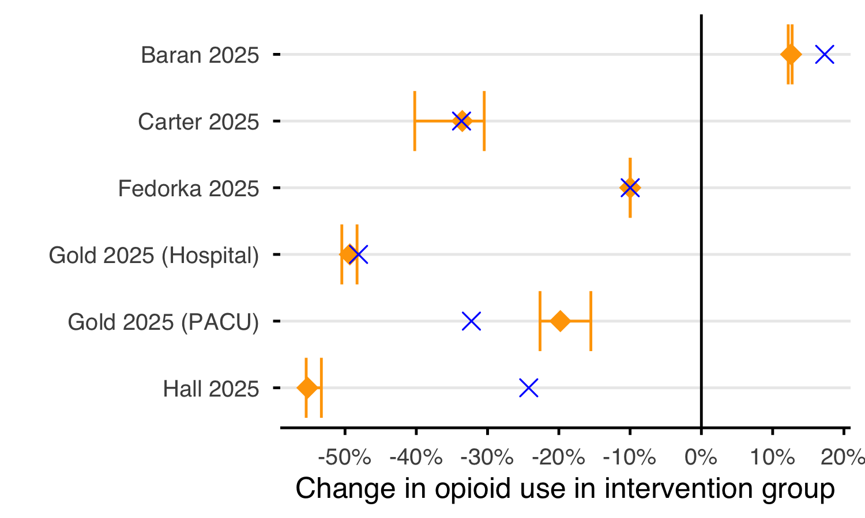
Figure 1.1: Forest style plot illustrating the percentage change in opioid use associated with an intervention. Blue cross denote the study reported outcome. Orange diamond and error bar denote the the primary point estimate and range using different conversion values.

1.4 Discussion
In observational research, it will be rare for the result to have no measurement bias. The influence of the bias in the conversion value is a considerable problem; the degree of error to the biological ground truth can never be known and estimates very^{11, 12}. Where a non-zero treatment association exists ($Δμ^{0}≠0$), condition 2 cannot hold, because $Δ{\overset{‾}{d}}_{i}=0 ∀i$ implies $ΔD=0$ and hence $Δμ^{0}=0$.
An RCT may offer hope of reducing the TOB bias, however if a collider bias occurs (where the treatment itself has an effect on the choice of analgesia used¹³) or the post-operative analgesia treatment is not protocolised, the mean doses between groups will diverge and the bias will increase. Regardless of the design, any study reporting TOB outcome metrics should assess the degree of bias in the context of the minimum clinically important difference to ensure the results and conclusions are interpreted accurately.
This study is limited by only simulating a two opioid paradigm and by comparing group means; the extent of the bias in multiple opioid studies or comparison of group medians has not been investigated. Furthermore, the literature search was exploratory rather than systematic and may not be representative of the wider literature.
We recommend that all studies using opioid equivalence metrics should publish the mean doses of the opioids within each group and cite the conversion tables used.

2. Author contributions
Conceptualization: DW, MW and SH
Data curation: DW
Formal analysis: DW
Funding acquisition: MW and SH
Methodology: DW
Supervision: MW and SH
Visualization: DW
Writing - original draft: DW
Writing - review & editing: DW, MW and SH

3. Acknowledgements
The authors wish to thank the following for their support: Dr Thomas Frost for early direction and support, Dr Yogini Jani for feedback, University College London Hospitals National Health Service Foundation Trust Critical Care Special Interest Project Scheme and the University College London Health Algorithm Laboratory.

4. Disclosure of interests
The authors declare that they have no conflict of interest

5. Funding
DW is supported by the Engineering and Physical Sciences Research Council (EP/Y034929/1). MW and SH are supported by the National Institute for Health Research (NIHR) Central London Patient Safety Research Collaboration (NIHR 204297). SH and DW are supported by the NIHR University College London Hospitals National Health Service Foundation Trust and University College London Biomedical Research Centre. The views expressed in this study are those of the authors and do not necessarily reflect those of the NIHR or the Department of Health and Social Care.

6. Declaration of Generative AI and AI-assisted technologies in the writing process
During the preparation of this work the authors used Anthropic’s Claude Opus 5 in order to produce virtual peer review. After using this tool, the authors reviewed and edited the content as needed and take full responsibility for the content of the publication.

References
1. Bhatnagar M, Pruskowski J. Opioid Equivalency. StatPearls Treasure Island (FL): StatPearls Publishing; 2026.
2. McPherson MLM. Demystifying opioid conversion calculations: A guide for effective dosing. Bethesda, MD: American Society of Health-System Pharmacists; 2010.
3. Nielsen S, Degenhardt L, Hoban B, Gisev N. A synthesis of oral morphine equivalents (OME) for opioid utilisation studies. Pharmacoepidemiology and Drug Safety 2016; 25: 733–7
4. Dowell D, Ragan KR, Jones CM, Baldwin GT, Chou R. CDC Clinical Practice Guideline for Prescribing Opioids for Pain — United States, 2022. MMWR Recommendations and Reports 2022; 71: 1–95
5. Mercadante S, Adile C, Ferrera P, Grassi Y, Cascio AL, Casuccio A. Conversion ratios for opioid switching: A pragmatic study. Supportive Care in Cancer 2023; 31: 91
6. Keogh RH, Shaw PA, Gustafson P, et al. STRATOS guidance document on measurement error and misclassification of variables in observational epidemiology: Part 1—Basic theory and simple methods of adjustment. Statistics in Medicine 2020; 39: 2197–231
7. Morris TP, White IR, Crowther MJ. Using simulation studies to evaluate statistical methods. Statistics in Medicine 2019; 38: 2074–102
8. Moher D, Shamseer L, Clarke M, et al. Preferred reporting items for systematic review and meta-analysis protocols (PRISMA-P) 2015 statement. Systematic Reviews 2015; 4: 1
9. Fedorka CJ, Tornberg HN, Rivera-Pintado C, et al. Liposomal Bupivacaine + Bupivacaine Versus Bupivacaine Interscalene Nerve Block Effect on Pain After Rotator Cuff Repair: A Randomized Control Trial. J Am Acad Orthop Surg United States; 2025; 34: e2216–25
10. Carter M, Narayanan R, Toci G, et al. Inpatient Multimodal Pain Regimens Do Not Impact Hospital Length of Stay or Long-term Postoperative Opioid Use Following 1 and 2-Level Lumbar Fusion. Clin Spine Surg United States; 2025; 38: 368–73
11. Rennick A, Atkinson T, Cimino NM, Strassels SA, McPherson ML, Fudin J. Variability in Opioid Equivalence Calculations. Pain Medicine 2016; 17: 892–8
12. Yessaillian A, Reese M, Clark RC, et al. A systematic review of morphine equivalent conversions in plastic surgery: Current methods and future directions. Journal of plastic, reconstructive & aesthetic surgery: JPRAS 2024; 95: 142–51
13. Pearl J, Mackenzie D. The book of why: The new science of cause and effect. London: Penguin Books; 2019.
14. Veritas Health Innovation. Covidence systematic review software. Melbourne, Australia: Veritas Health Innovation; 2026.
15. Wan X, Wang W, Liu J, Tong T. Estimating the sample mean and standard deviation from the sample size, median, range and/or interquartile range. BMC medical research methodology 2014; 14: 135
16. Baran O, Şahin A, Gürkan S, Gür Ö, Arar C. Optimizing Analgesia After Minimally Invasive Cardiac Surgery: A Randomized Non-Inferiority Trial Comparing Interpectoral Plane Block Plus Serratus Anterior Plane Block to Erector Spinae Plane Block. J Clin Med Switzerland; 2025; 14: 3786

Appendix A — Mathematical Proofs

A.1 Introduction
As a research metric, measuring differences in group means intends to measure the difference in total scale of the groups, known as the associational effect (or treatment effect in causal work), to assess if an intervention applied to one group is associated (or causes) a reduction in the total amount of opioids.
We will demonstrate that the measured difference in means is equal to true difference in means when the following conditions are met:
- There is no error in the conversion value used: $ϵ_{i}=0 ∀i$
- The drug mean dose between groups are equal: $Δ{\overset{‾}{d}}_{i}=0 ∀i$

A.2 Definitions
The Total Opioid Burden $\text{TOB}$ for a given patient over a given timeframe is the sum of the doses $d$ of medications $i$ multiplied by the conversion value $c$ for the given medication via the route $r$.
TOBj=i∈M​di,jci,r (A.1)
The conversion value $c_{i}$ is the unknown ground truth conversion value $c_{i}^{0}$ with the error term $ϵ_{i}$ of the given medication in the published value. It is noted that there is no error term in the doses given $d$ term.
$$c_{i}=c_{i}^{0}+ϵ_{i} (A.2)$$
The group mean TOB can be rearranged from Equation 1.1 as a sum of weighted means where $μ_{\text{TOB},G}$ is equal to the sum ${\overset{‾}{d}}_{i,G}$ multiplied by the conversion value $c_{i}$.
μTOB,G=1nGj∈G​i∈M​di,jci (A.3)
The mean dose of a given medication within a given group ${\overset{‾}{d}}_{i,G}$ is defined as the arithmetic mean of the doses $d$ of the medication for the patients within the group.
di,G=1nGj∈G​di,j (A.4)
The group’s total opioid exposure $D_{G}$ (also known as the group total opioid requirement) is the sum of the mean dose ${\overset{‾}{d}}_{i}$. This is the pooled drug-milligram, not the group total $\text{TOB}$ calculated in Equation A.3.
DG=i∈M​di,G (A.5)
The proportion $p_{i,G}$ of medication $i$ within a group $G$ is defined as the mean dose of the medication divided by the group total exposure $D_{G}$. The sum of the proportions within a group is equal to 1.
$$p_{i,G}=\frac{{\overset{‾}{d}}_{i,G}}{D_{G}} (A.6)$$
i​pi,G=1 (A.7)
Let $\overset{‾}{D}$ be the average opioid exposure where $\overset{‾}{D}=\frac{1}{2}(D_{T^{1}}+D_{T^{0}})$.
Let $ΔD$ be the difference in group exposure where $ΔD=D_{T^{1}}−D_{T^{0}}$.
Let ${\overset{‾}{p}}_{i}$ be the average proportion where ${\overset{‾}{p}}_{i}=\frac{1}{2}(p_{i,T^{1}}+p_{i,T^{0}})$.
Let $Δp_{i}$ be the difference in proportion where $Δp_{i}=p_{i,T^{1}}−p_{i,T^{0}}$.

A.3 Rearrangement of Equation A.3
The mean dose of the medication ${\overset{‾}{d}}_{i,G}$ can be rearranged as the groups total opioid exposure $D_{G}$ scaled by the proportion $p_{i,G}$
$${\overset{‾}{d}}_{i,G}=p_{i,G}D_{G} (A.8)$$
Substituting Equation A.8 into Equation A.3 provides the group mean dose expressed as the groups total opioid exposure $D_{G}$ multiplied the the proportion weighted sum of the conversion values.
μTOB,G=DGi​pi,Gci (A.9)
Equation A.9 demonstrates that the group mean TOB can vary due to either the total scale of the group ($D_{G}$) and/or the mixture of opioids within the group.

A.4 Proof of bias
Let $G∈\{T^{0},T^{1}\}$ index the control and intervention groups of size $n_{T=0}$ and $n_{T=1}$.
Let $M=\{\text{morphine},\text{oxycodone},...\}$ index the opioid types.
The difference in group means $Δμ$ is
$$\begin{aligned}Δμ&=μ_{\text{TOB},T^{1}}−μ_{\text{TOB},T^{0}} \\ &=D_{T^{1}}∑p_{i,T^{1}}c_{i}−D_{T^{0}}∑p_{i,T^{0}}c_{i}\end{aligned} (A.10)$$
The conversion value can then be substituted with Equation A.2 and split into the true effect $Δμ^{0}$ and the bias $B$. Throughout, $Δ$ and bar notation follow the $T^{1}−T^{0}$ (intervention minus control) convention.
Δμ=DT1i​pi,T1ci0−DT0i​pi,T0ci0⏟Δμ0, true difference+DT1i​pi,T1ϵi−DT0i​pi,T0ϵi⏟B, bias (A.11)
Substituting Equation A.8 into the bias term of Equation A.11 gives an equivalent drug-wise form of the bias, where $Δ{\overset{‾}{d}}_{i}={\overset{‾}{d}}_{i,T^{1}}−{\overset{‾}{d}}_{i,T^{0}}$.
B=i​ϵiΔdi (A.12)
Equation A.12 can also be written as Equation A.13.
B=Di​ϵiΔpi+ΔDi​ϵipi (A.13)

A.5 Conclusion
The measured difference $Δμ$ equals the true difference $Δμ^{0}$ if and only if
B=0⇔Di​ϵiΔpi=−ΔDi​ϵipi⇔i​ϵiΔdi=0 (A.14)
Conditions where this is satisfied:
- No conversion error: Every conversion value is correct, so the bias is zero whatever the group composition.
$$ϵ_{i}=0 ∀i⟹B=0$$
- Mean dose does not differ between groups: Each medication has the same mean dose in both groups.
$$Δ{\overset{‾}{d}}_{i}=0 ∀i⟹B=0$$
It is noted that there are a range of other possible special and general conditions where Equation A.14 can be satisfied and hence there will be no bias.

Appendix B — Simulation Studies

B.1 Introduction
Two simulated studies were performed to demonstrate the sensitivity of the total opioid burden (TOB) metric to differences in the proportions of medications between groups and the conversion values used. In both simulations, the outcome measured is the difference in group mean TOB, there was no treatment effect so this is expected to be 0. Additionally, the ground truth value for oxycodone to morphine is set to 1.75, to give a similar but not exact value to the commonly accepted potency of 2, compared to oral morphine.
The first (Section B.2.1) uses a simplified simulation with between groups to understand the variation in results across the full range of parameters.
The second simulation (Section B.2.2) uses a hypothetical study setup across a range of realistic values to establish the extent of the variation in results under commonly seen situations.

B.1.1 Aims
To demonstrate the direction and extent of a bias when comparing group means of TOB metrics between groups with differing opioid proportions and with an error in the conversion values.

B.2 Data generating mechanisms

B.2.1 Simple simulation
10,000 samples were divided equally between a control and intervention group. An opioid of either morphine or oxycodone was then sampled from a distribution set by $Δp_{i}$ to set the proportion $p$ of each opioid to be reciprocal in each group (${\overset{‾}{p}}_{i}=0.5$). An opioid requirement ($D$) was sampled from a normal distribution ($E[D]=$ 10 with $σ=$ 0.1) for both groups enforcing a treatment association of 0% ($ΔD=0$).
For samples where the opioid assigned was morphine, the total morphine dose was set equal to the opioid requirement ($d_{\text{morphine}}=D∴ c_{\text{morphine}}^{0}=1,ϵ_{\text{morphine}}=0$. For samples where the opioid was oxycodone, the total oxycodone dose was set to opioid requirement divided by the ground truth potency ($c_{\text{oxycodone}}^{0}$) equal to 1.75 ($d_{\text{oxycodone}}=\frac{D}{c_{\text{oxycodone}}^{0}}$). For all samples, the opioid consumed was then converted into a TOB, using a conversion value of 1 for morphine and 1.75 +/- an error, $ϵ$, for oxycodone. The measured difference between the group mean of the control and intervention groups ($Δμ=μ_{\text{TOB, intervention}}−μ_{\text{TOB, control}}$) was then calculated. The reference opioid used was oral morphine so the resulting units of the TOB metric are oral morphine equivalence milligrams (OMEmg).

B.2.2 Hypothetical study simulation
A hypothetical study was designed to emulate a retrospective cohort study to compare a surgical intervention on the postoperative opioid requirement. The study set-up is outlined in Note B.1.
 Note B.1: Hypothetical study design
A research team wish to understand if the use of a robot for a surgical procedure, reduces the post-operative pain. They design a retrospective cohort study for patients treated with a robotic procedure and those without. The primary outcome is the total opioid requirement, as measured in OME mg, in the first 24 hours post-operatively as a surrogate for the total pain caused by the surgical procedure.
The annual case volume is 30, these were all performed using non-robotic surgery until 1 Jan 23 when a robot was acquired, and since 80% of cases are performed with the robot. All EHR data was collected between 1 Jan 20 and 31 Dec 25. All patients are treated with a Patient Controlled Analgesia (PCA) after their operation and on average the anaesthetist will prescribe a morphine PCA to 50% of patients and an oxycodone PCA to the remainder. No other opioid medication was administered.
During the study there was a national shortage of oxycodone from 2024-01-01 to 2024-12-31 and at which time all patients were prescribed a morphine PCA. Whilst the authors described this in their methods section, they concluded that it would not impact their results, as the differing opioids were already accounted for in their OME metric.

The difference in proportion ($Δp_{i}$) between groups is simulated using a medication shortage that, due to temporal differences between the groups, impacts the treatment group to a greater extent. The ground truth potency of oxycodone is set to 1.75. The post-operative opioid requirement was sampled from a normal distribution ($E=$ 50 mg with $σ=$ 10 mg) with the average treatment effect of the intervention is set to -5 TOB mg. TOB was calculated as per described previously.

B.2.3 Estimand
Across all simulations the estimand is the true associational effect of the treatment group $Δμ^{0}$.

B.3 Performance measure
Across all simulations the performance measure is the difference in the expected group mean difference and the observed group mean difference $Δμ_{\text{TOB}}$

B.4 Methods
The first simulation was then performed once for the range of grid values for $Δp_{i}∈$ -1, 1 and $ϵ∈$ -100%, 100% with all other parameters fixed.
The second simulation was performed once with parameters specified in Note B.1 and repeated across each of the grid values for the rate of post-operative morphine prescribed between 100% and 0% with conversion values of oxycodone:morphine between 1:1 and 3:1. The result for each study was the measured difference between the group mean of the control and intervention groups ($Δμ_{\text{TOB}}$), the observed difference in proportion ($Δp_{i}$) and the error in the conversion value ($ϵ$).
All simulations were performed in R version 4.6.1 (2026-06-24), using seed 222 code is available on Github.

B.5 Results

B.5.1 Simple simulation
2,911 different simulations where performed across the grid values of $Δp_{\text{oxycodone}}$ and $ϵ$. Figure B.1 demonstrates the observed difference between groups ($Δμ_{\text{TOB}}$) plotted against the difference in the proportion of morphine in the intervention group over the percentage error in the conversion value $ϵ$.
Where the conversion value is equal to the ground truth ($ϵ$ = 0%) or the proportion of opioids in each group are matched ($Δp_{i}$ = 0) then the observed group difference is equal to the true treatment association.
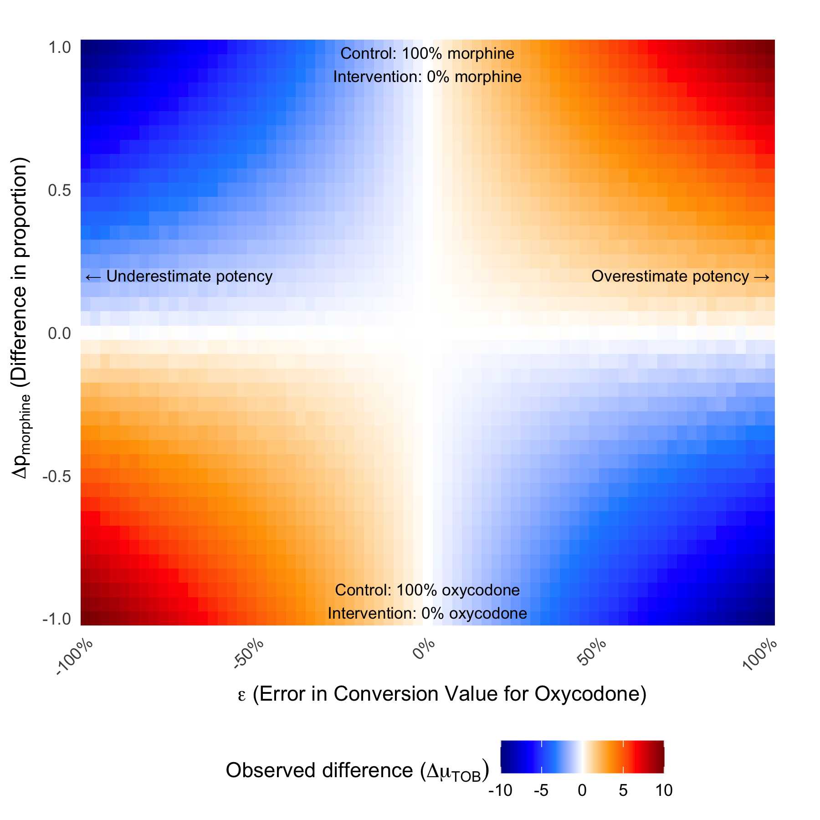
Figure B.1: Observed total opioid burden (TOB) group mean difference across difference in opioid proportion and error in the conversion value - Heatmap of the observed difference in group means ($Δμ_{\text{TOB}}$) across grid values of $Δp_{i}$ (difference in opioid proportion between groups) and $ϵ$ (error in the oxycodone conversion value).

B.5.2 Hypothetical study simulation
180 procedures were simulated using the parameters described in Section B.2.2.
Table B.1: Demographic table of simulated study population. Count data by opioid with treatment group proportion provided in bracked. Group mean OME totals with standard deviation shown.
Characteristic | Overall N = 180¹ | Non-robotic N = 105¹ | Robotic N = 75¹ | p-value²
Opioid |  |  |  | 0.11
morphine | 115 (64%) | 62 (59%) | 53 (71%)
oxycodone | 65 (36%) | 43 (41%) | 22 (29%)
TOB (mg) | 46.5 (9.7) | 48.0 (9.2) | 44.5 (10.2) | 0.010
¹n (%); Mean (SD)
²Pearson's Chi-squared test; Wilcoxon rank sum test
A simple demographics table for the study is shown in Table B.1, this demonstrates the unequal distributions of opioids between groups. Figure B.2 (a) shows that within the robotic and non-robotic groups the proportion of each opioid is not equal, and the effect of the oxycodone shortage has had a larger impact on the robotic group. Figure B.2 (b) demonstrates this distribution of the total opioid burden (OME mg) of patients in the robotic and non-robotic patients.
  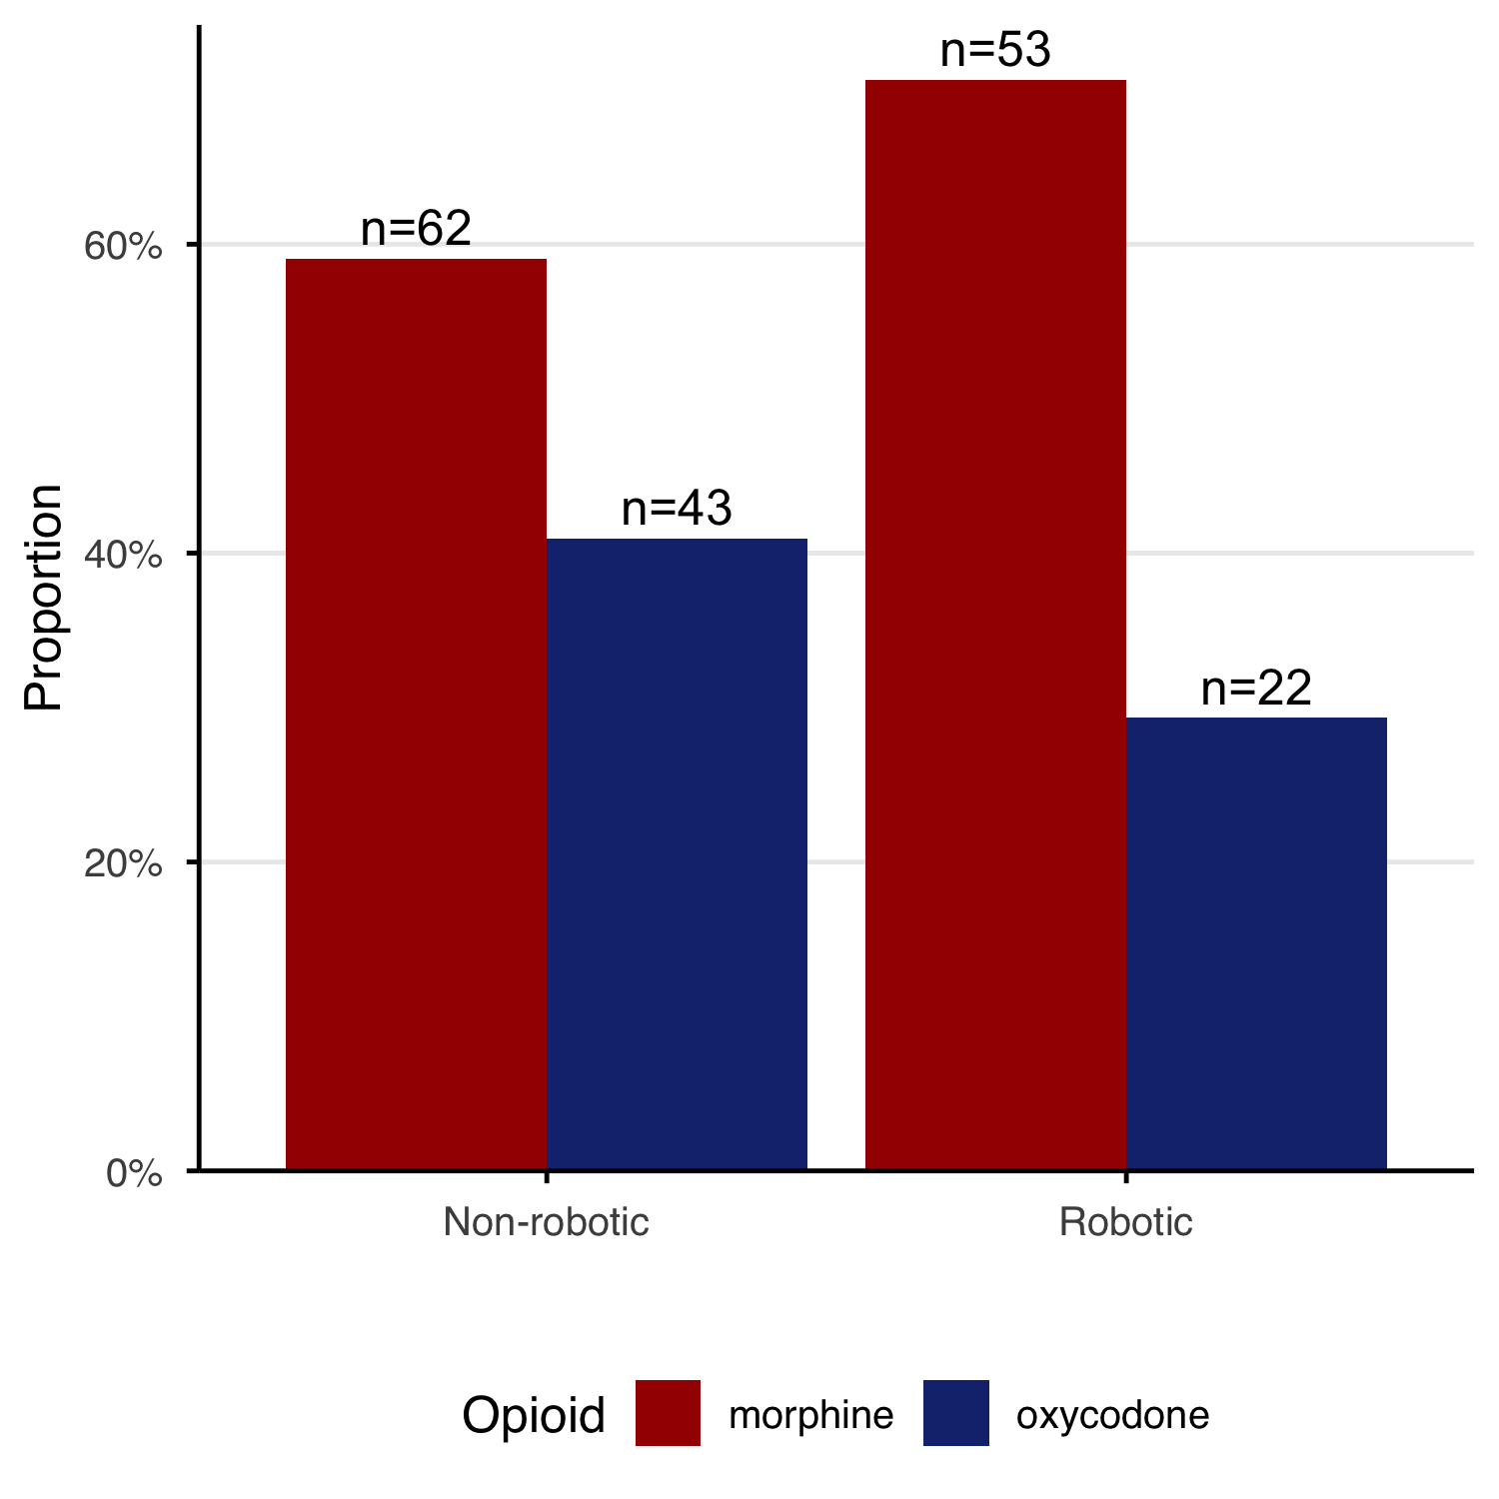
  (a) Opioid prescribing proportions by surgery type - Proportion and count of each opioid prescribed within robotic and non-robotic surgery groups.
  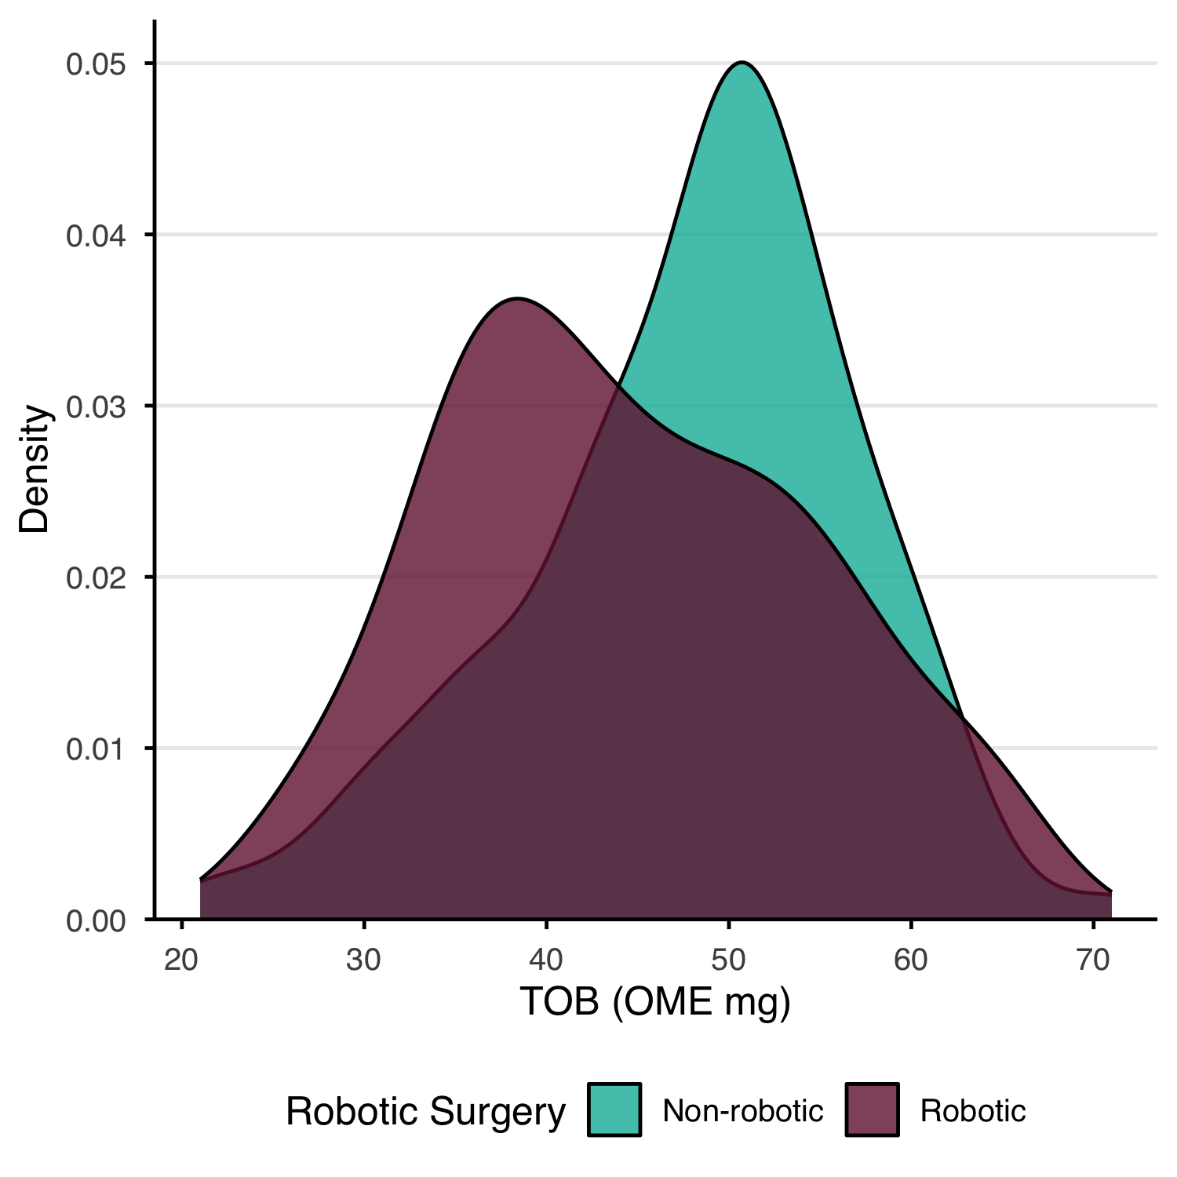
  (b) OME distribution by surgery type - Kernel density of calculated OME (OME mg) for robotic and non-robotic surgery groups.
Figure B.2: Opioid prescribing and OME distribution by surgery type
The results in Table B.1 represent a single sample of 180 patients that is subject to the variation induced in the random sampling. For this specific sample the observed treatment association of -7.32%.
To reduce the effect of random sampling, the simulation was repeated with the same parameters 500 times.
The mean opioid burden value for the robotic surgery group was 45.3 TOB mg and for the non-robotic surgery group was 48.9 TOB mg. This gives an observed effect size of the robot as -3.61 TOB mg compared to the realised true effect of -10% TOB mg (nominal -5 TOB mg), giving a bias of 1.391 TOB mg.

B.5.3 Verification of Equation A.13
Using Equation A.13 we can verify the simulation bias is as expected given the parameters.
Let $T^{1}$ be the group treated with the robot and $T^{0}$ be the group treated non-robotically.
Let $ϵ_{\text{morphine}}$ be 0 and $ϵ_{\text{oxycodone}}$ be $c_{\text{oxycodone}}−c_{\text{oxycodone}}^{0}$ which is -0.25.
The values of ${\overset{‾}{d}}_{i,T}$ are observed from the simulation from Table B.2 as the mean dose of the opioid within each treatment group. The value of $D_{T}$ is calculated from the sum of the mean doses ${\overset{‾}{d}}_{i}$ within group $T$. The values of $p_{i,T}$ are calculated using ${\overset{‾}{d}}_{i,T}$ and $D_{T}$ (Equation A.6).
Table B.2
$T$  Group | $i$  Opioid | $n_T$  Group size | $\sum_{T} d_i$  Sum dose (mg) | $\bar{d}_{i,T}$  group mean dose (mg) | $D_T$  group total exposure (mg) | $p_{i,T}$
Robotic | morphine | 35996 | 1145795 | 31.83 | 40.81 | 0.7800
Robotic | oxycodone | 35996 | 323119 | 8.98 | 40.81 | 0.2200
Non-robotic | morphine | 54004 | 1485587 | 27.51 | 41.77 | 0.6585
Non-robotic | oxycodone | 54004 | 770308 | 14.26 | 41.77 | 0.3415
Using the provided values in the bias equation Equation A.13 yields the following:
$\overset{‾}{D}$ = 0.5(40.81 + 41.77) = 41.29
$ΔD$ = 40.81 - 41.77 = -0.97
${\overset{‾}{p}}_{\text{morphine}}=$ 0.5(0.78 + 0.6585) = 0.7193
${\overset{‾}{p}}_{\text{oxycodone}}=$ 0.5(0.22 + 0.3415) = 0.2807
$Δp_{\text{morphine}}=$ 0.78 - 0.6585 = 0.1215
$Δp_{\text{oxycodone}}=$ 0.22 - 0.3415 = -0.1215
Applying Equation A.13 yields the following estimate of bias
$B$ = 41.29((0 x 0.1215)+(-0.25 x -0.1215)) + -0.97 ((0 x 0.7193)+(-0.25 x 0.2807))
$B$ = 1.3218 $≈$ 1.3913
This estimate of 1.3218 approximates the observed bias of from the simulation of 1.3913 within the variation attributable to random sampling thus confirming bias equation.
Figure B.3 demonstrates that with subsequent simulations the mean estimated effect converges with the value of the the true effect combined with the bias. This emphasises that increasing statistical power with the same experimental set-up will not eliminate or reduce the effect of the bias.
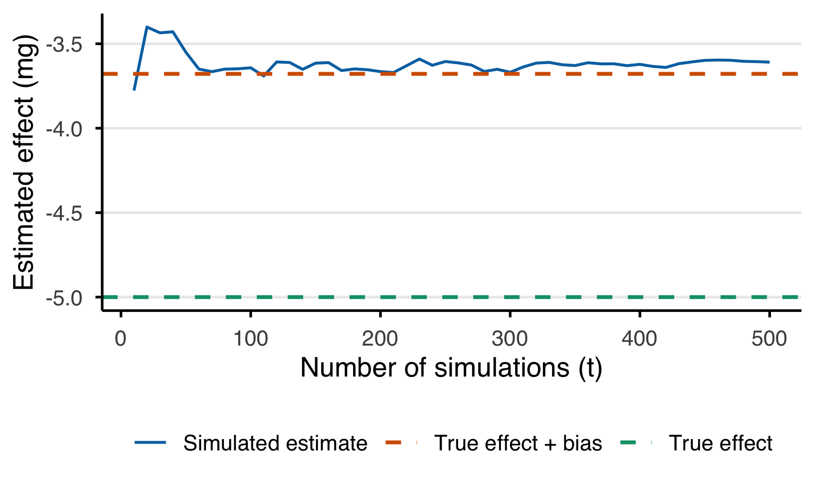
Figure B.3: Line chart demonstrating the convergence of the esimated effect on the value of the true effect combined with the bias. The solid blue line shows the running estimate of the effect after t simulations. The orange line marks the true effect plus bias. The green line marks the true effect.

B.5.4 Impact of conversion set and proportions
The hypothetical study was repeated using the grid values of different conversion values and different proportion of postoperative oxycodone prescribing. The prior was informed by ranges observed in the literature and the latter to influence the degree of different in opioid proportions between groups. For each set of grid values, 20 were performed and the mean observed difference calculated. Given a 50 mg expected opioid requirement and a treatment effect of -10% it is expected the observed difference of the robotic group to be -5 mg.
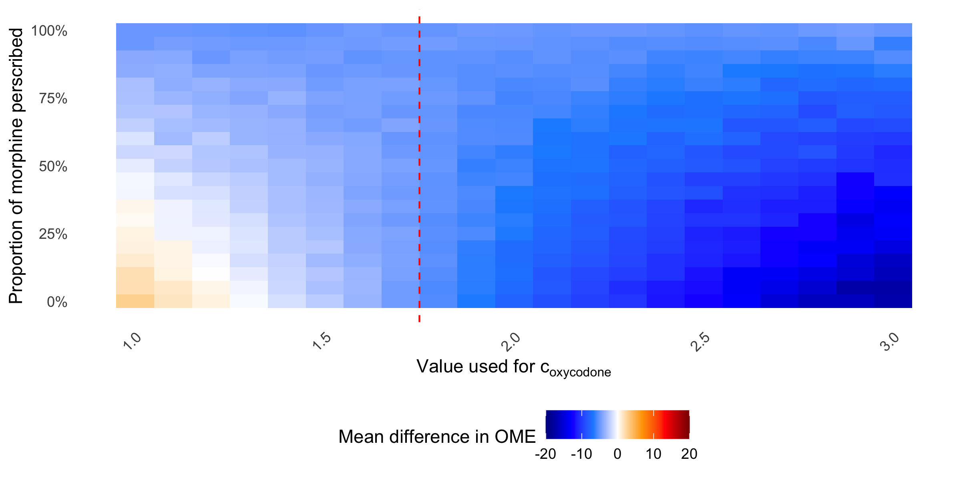
Figure B.4: Sensitivity of observed treatment effect to conversion value and opioid proportion - Grid search results showing the observed treatment effect across oxycodone conversion values and post-operative morphine prescribing proportions. True treatment effect is -5 mg. The dashed line indicates the ground truth conversion value.
Figure B.4 is a heat map of the mean observed difference of each of the grid values of the postoperative prescribing of morphine rates and the conversion value of oxycodone used.
Where the proportion of post-operative morphine prescribing is close to 100%, the exogenous effect of an oxycodone shortage has little diverging impact on the proportions of opioids between groups, thus the true treatment effect of -5 mg OME is recovered. However, were the rate of postoperative morphine prescribing is lower,the oxycodone shortage causes further divergence of the proportions between groups, resulting in wider variation in the observed difference. Where the conversion value supplied is close to the ground truth (as indicated by the red line) then the error is low. At the extreme, the maximum and minimum values are 2.85 mg and -17.43mg respectively.
Figure B.5 demonstrates the experiment space for the hypothetical study simulation values where $Δp_{i}<0$ and for values of $−0.5<ϵ<1$. Despite being a relativity narrow section of the possible grid space detailed in Section B.5.1 with a modest effect size of -5 OME mg there are still values where the observed effect size is significantly different.
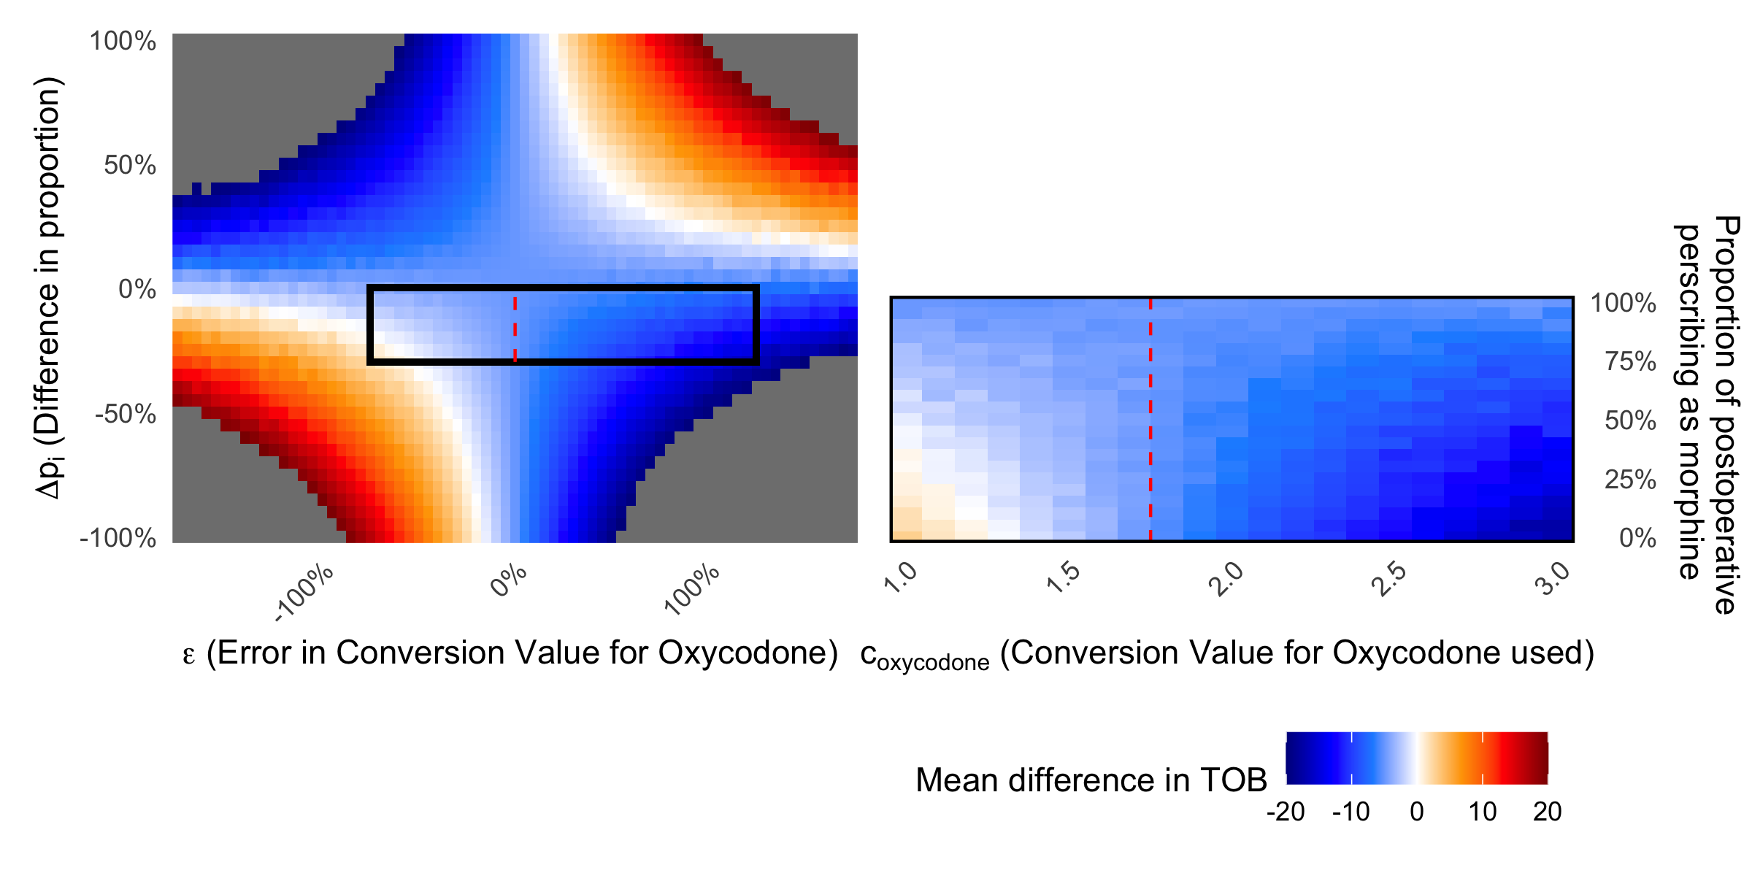
Figure B.5: Hypothetical study simulation parameters mapped onto the simple simulation space - Side by side comparison of the simple and exemplar simulation grids. The region explored by the hypothetical study experiment (Δp_i < 0; −0.5 < ε < 1) is overlaid on the full simple simulation space.

Appendix C — Exploratory Literature Search

C.1 Introduction
Given the mathematical proof and the results of the simulation, an exploratory search of the literature was performed to establish a formal systematic literature search protocol. The intention of the literature search is to understand to what extent does the current literature describe TOB methodology and if it was possible to estimate the bias in published works. To formally calculate the bias the error in the conversion value is needed which requires the knowledge of the biological ground truth. As this is not possible, a range of different conversion values, each with their own unknown error was used to as a proxy for a range of conversion value errors.

C.2 Methods
A informal search of literature to understand the use of opioid equivalence metrics in peri-operative and surgical studies published in 2025 was performed. A search of the PUBMED database was performed on 7th July 2026 using the following search string.
PUBMED search term
((((((“opioid equivalent” OR “oral morphine equivalence” OR “oral morphine equivalent” OR “oral morphine equivalents” OR “OME” OR “morphine milligram equivalents” OR “morphine milligram equivalence” OR “MME” OR “morphine equivalent daily dose” OR “MEDD”) AND (“perioperative” OR “peri-operative” OR “postoperative” OR “post-operative” OR “surgical” OR “surgery” OR “post-surgical” OR “postsurgical”))) AND (“2025/01/01”[Date - Publication] : “2025/12/31”[Date - Publication]))) AND (“clinical trial”[Filter] OR “clinical trial” OR “controlled clinical trial” OR “randomized controlled trial” OR “interventional” OR “intervention study” OR “clinical trials as topic”[MeSH Terms] OR “cohort studies”[MeSH Terms] OR “cohort” OR “prospective” OR “retrospective” OR “case-control” OR “comparative study” OR “evaluation study”))
Primary and full text screening was carried out using the inclusion criteria detailed in Table C.1 by one author.
Table C.1: Litrature extraction proforma
Criteria | Include | Exclude
Population | All patient groups undergoing a surgical procedure | Patients not undergoing surgical procedures. Non-human studies
Concept | Studies using a total opioid burden metric as a primary or secondary outcome (Such as oral morphine equivalence (OME), milligram morphine equivalence (MME) or opioid equivalence) | Outcomes not including opioid totals
Context | Patients undergoing surgical procedures | Palliative care studies or Pharmacology studies
Other | Any studies comparing a control against and intervention or two interventions.

Papers where ordered randomly within the Covidence platform and data was extracted from a random subset by a single author as presented by the platform¹⁴. Primary Data extraction was performed using a drop down selection proforma including study design, methodology and reporting of total opioid metrics. Free text notes were collected to aid secondary data collection.
For each paper where group average doses of each opioid were described, these were extracted. If only median values were provided, an estimated mean was calculated using Wan’s 2014 approximation ($\hat{d_{i}}=\frac{Q_{1}+M+Q_{3}}{3}$ ) to preserve the linearity with in the arithmetic mean¹⁵. Where opioid routes where not provided then IV was assumed and where conversion values were not provided, the Nielsen set was used³.
The group mean of total opioid burden reported by the paper was extracted. Then using the mean doses and the conversion values provided, the group mean was calculated independently. Following this, all possible group means were calculated by applying each of the possible values provided in Table 1 of Neilsens Conversion set (summarised in Table C.2), as the range of plausible conversion values an author may use³.
Table C.2
Medication | Conversion values
morphine | 2
fentanyl | 100, 150, 200, 300
oxycodone | 3
tramadol | 0.1, 0.2, 0.25
hydromorphone | 15, 20
hydrocodone | 1, 1.33

C.3 Results

C.3.1 Reporting of opioid burden metrics
480 studies were identified in the rapid literature search, a sample of 83 that fit the eligibility had data extracted. The majority of studies were cohort studies and most common intervention was anaesthetic interventions (Figure C.1).
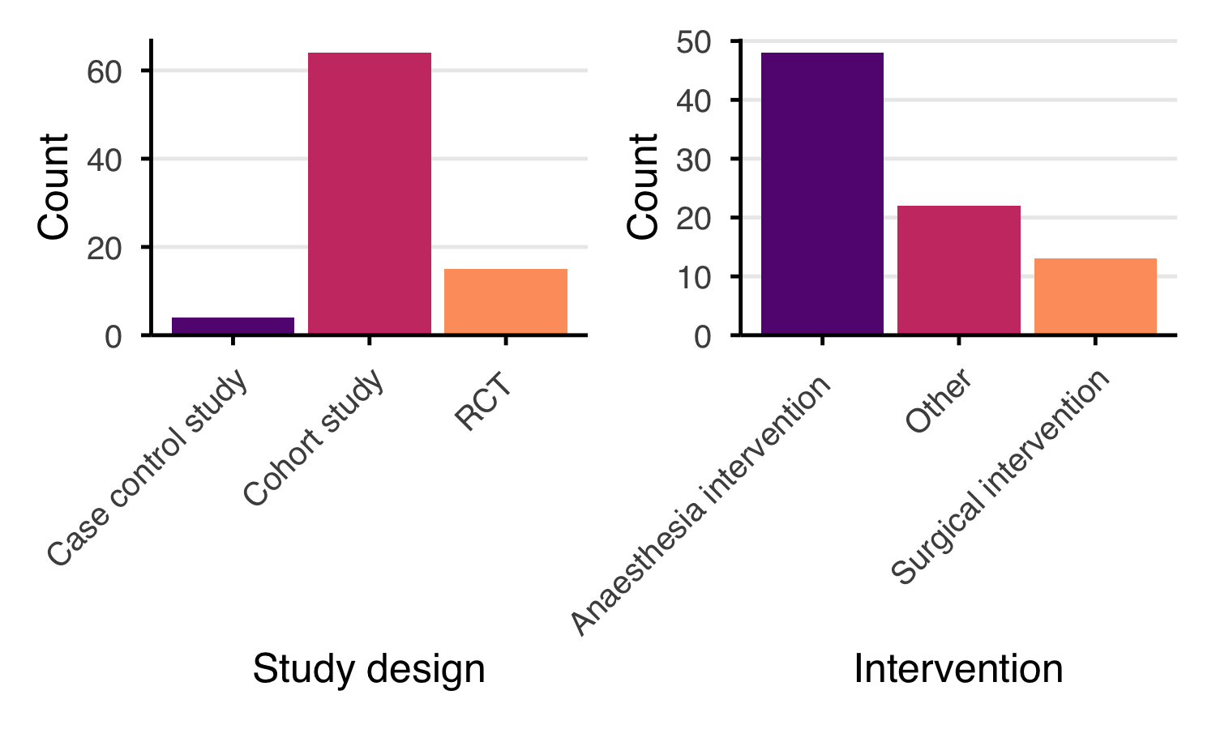
Figure C.1: Study design and intervention types in included literature - Bar charts summarising the study design and intervention type of studies included in the rapid literature review. Left panel shows count by study design; right panel shows count by intervention type.
With regards to the opioid conversion sets used, 24 (29%) cited another source, whilst 3 (4%) included the conversion values within the paper. 56 (67%) papers did not include any citation or description of the opioid conversion sets used. 8 (10%) papers described the proportions of different opioids between intervention groups (Figure C.2). Of these 8 papers, 3 provided count data only and not mean/median dose for each opioid within treatment groups.
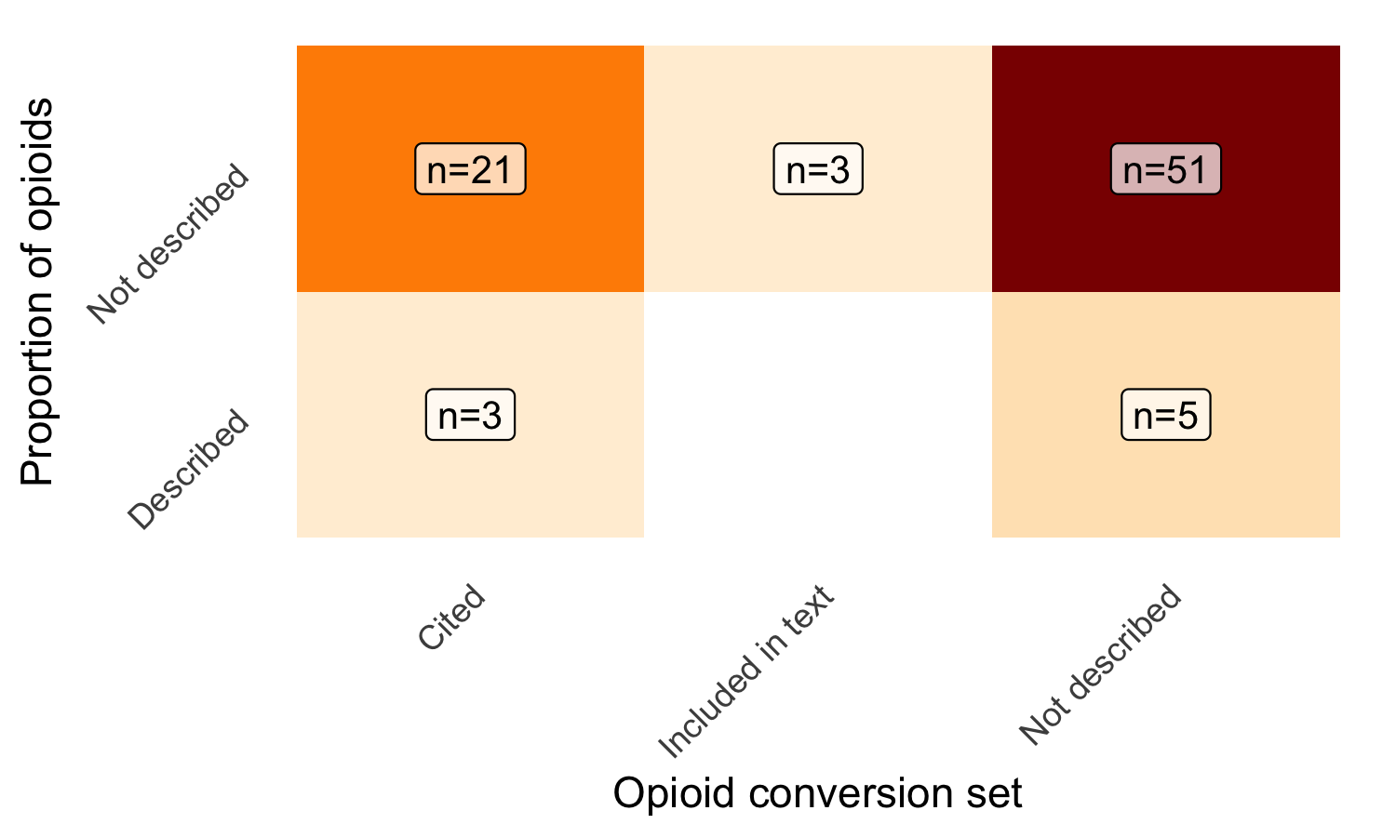
Figure C.2: Opioid conversion set reporting and within-group proportion documentation - Heatmap showing the count of studies by opioid conversion set type and whether opioid proportions within groups were reported. Cell counts are displayed as text labels.

C.3.2 Impact of varying conversion values on studies
Table C.3 details the 5 studies where opioid proportions could be recovered. Of note, only Baran cited a opioid conversion set¹⁶, all other authors did not describe which value sets were used. Two studies were randomised controlled trials (RCT), whilst the remainder were retrospective cohort studies. With regards to the interventions analysed, in this subset, all were concerning analgesia either during or after the surgical procedure and were classed as anesthesia interventions.
Table C.3: Summary table of litrature articles that presented breakdown by opioid groups.
Authors | Title | Study design | Population | Control group | Intervention group | Opioid conversion set included
Baran 2025 | Optimizing Analgesia After Minimally Invasive Cardiac Surgery: A Randomized Non-Inferiority Trial Comparing Interpectoral Plane Block Plus Serratus Anterior Plane Block to Erector Spinae Plane Block. | RCT | Patients aged 18–75 years scheduled for their first minimally invasive cardiac surgery with ASA score I-III | Erector spinae plane block (ESPB) | ESPB plus Serratus anetrior plane block | Cited
Fedorka 2025¹ | Liposomal Bupivacaine + Bupivacaine Versus Bupivacaine Interscalene Nerve Block Effect on Pain After Rotator Cuff Repair: A Randomized Control Trial. | RCT | Adults undergoing arthroscopic rotator cuff repair with a planned interscalene nerve block | Bupivicaine | Liposomal bupivicaine | Not described
Carter 2025² | Inpatient Multimodal Pain Regimens Do Not Impact Hospital Length of Stay or Long-term Postoperative Opioid Use Following 1 and 2-Level Lumbar Fusion. | Cohort study | Patients aged18 or older who had undergone either a posterior lumbardecompression and fusion (PLDF) or transforaminallumbar interbody fusion (TLIF) from 2018 to 2019 | Opioid only postop analgesia | Multimodal postop analgesia | Not described
Hall 2025³ | Ketamine as part of multi-modal analgesia may reduce opioid requirements following cardiac surgery: a retrospective observational cohort study. | Cohort study | Adult patients admitted for elective cardiac surgery | Standard postoperative analgesia | Postoperative analgeia with ketamine | Not described
¹Median values provided, converted to means
²Paper divided into Tramadol OME and non-tramadol OME, Only other opioid, beside tramadol in the multi-modal group was oxycodone. Assumes IV for conversion value of oxycodone. Outcome extracted for total in-hospital OME.
³Outcomes for Dose in PACU and total in hospital
Table C.4 provides three sets of results for the studies detailed. The first is the study reported outcomes, this is the mean total opioid burden for the control and intervention groups. From this an observed difference is calculated with a percentage change from the control. The second column set is the de-novo calculation, by using the mean dose of each opioid within each group and conversion set provided (or Neilsens if not) to attempt to calculate the control and intervention group means. From these de-novo estimates a second difference of the treatment group was calculated.
Finally, regardless of the conversion sets used, the de-novo calculation was repeated across the possible grid values of the Neilsen conversion set. The minimum and maximum possible differences were then extracted.
Table C.4: Table of reported outcomes and de-novo calalculated outcomes.
 | Study reported outcome |  |  | De Novo calculated outcome |  |  | Range of estimates
Authors | Control group | Intervention group | Difference | Control group | Intervention group | Difference | Lower bound | Upper bound
Baran 2025 | 178.0 | 208.8 | 30.8mg (17.3%) | 182.1 | 205.1 | 22.9mg (12.6%) | 22.9mg (12.2%) | 68.8mg (12.7%)
Fedorka 2025 | 43.7 | 39.4 | -4.4mg (-10.0%) | 87.5 | 78.7 | -8.7mg (-10.0%) | -13.1mg (-10.0%) | -13.1mg (-10.0%)
Carter 2025 | 315.0 | 209.0 | -106mg (-33.7%) | 314.5 | 209.0 | -105.5mg (-33.5%) | -119.8mg (-40.2%) | -98.4mg (-30.5%)
Gold 2025 (PACU) | 164.6 | 111.5 | -53.1mg (-32.3%) | 36.8 | 29.5 | -7.3mg (-19.8%) | -10mg (-22.6%) | -4.6mg (-15.5%)
Gold 2025 (Hospital) | 107.8 | 56.0 | -51.9mg (-48.1%) | 218.8 | 110.9 | -107.9mg (-49.3%) | -114.3mg (-50.4%) | -101.9mg (-48.3%)
Hall 2025 | 118.9 | 90.1 | -28.8mg (-24.2%) | 149.1 | 66.7 | -82.4mg (-55.3%) | -82.6mg (-55.4%) | -81.5mg (-53.3%)
This table highlights the difficulty in re-calculating the total opioid burdens that the authors have produced. This is likely due to a number of assumptions as details in the methods such as estimating mean values from medians and assuming medication routes. Only one study, Fedorka 2025, showed no sensitivity to the conversion value set used⁹. This is because, in the RCT only oxycodone was used in the post-operative period, as so whilst the group estimates may vary, the treatment effect percentage is fixed at 10%.
Figure C.3 demonstrates the reported difference in opioid burden (red cross) compared to the de-novo calculated difference (green cross). When the the grid search of the possible combinations of the values used by Neilsen was performed, the minimum and maximum values are demonstrated by the orange whiskers.
Figure C.3: Forest style plot illustrating the percentage change in opioid use associated with an intervention. Blue cross denote the study reported outcome. Orange diamond and error bar denote the the primary point estimate and range using different conversion values.

C.4 Discussion
There were some key learning points from the preliminary data collection that was integrated into the protocol as presented in Supplementary material D.
Search strategy - A single database was used for speed and ease, this was expanded to include 2 further databases sources.
Screening - A single reviewer with no verification was performed for speed and ease, a formal screening strategy was defined in the protocol. The inclusion criteria was narrowed to only include interventional study, this was due to a number of non-comparative observational trials being included in the primary data extraction. The full text screening stage was integrated into the primary data extraction in the proforma.
Data extraction - The primary and secondary data collection proformas were formalised in the protocol. For each field a descriptor was included to further define the value to be entered. The primary data collection proforma was focused to remove data points that were deemed no longer required.
Analysis plan - The analysis plan was formalised and analysis script defined.

Appendix D — Literature Rapid Review Of Total Opioid Burden Metric Methodology And Reporting Within Preoperative Care Research: Protocol
Registration: The rapid review protocol is pre-registered on the Open Science Framework

D.1 Introduction

D.1.1 Rationale
There are a wide range of different opioid used across the range of medical specialities and patient groups, each with their own potency to provide analgesia. Opioid conversion values have offered the ability to convert a specific opioid into the equivalent units of a reference opioid, usually morphine, to produce doses in oral morphine equivalent milligrams (OME mg) or milligram morphine equivalent (MME).
A number of conversion value tables have been published in an attempt to provide a best estimate of the conversion values between opioids. Within clinical practice, these cited value sets are a good surrogate for the true conversion value when used in opioid rotation5. Despite this, application of the value sets remains variable in both clinical and research practice.
It is unclear how well the methodology is described and reported within research.

D.1.2 Objectives
Primary research question: - Describe the methodologies of reporting of TOB metrics used in the perioperative literature.
Secondary research question(s)
- What proportion of study report the opioid proportions between comparative groups
- What proportion go study report the conversion values used to calculate the TOB metrics.
- To extract and calculate the outcomes de-novo for studies that publish the required minimum data of mean opioid doses within groups.

D.1.3 Methods
The eligibility criteria is set using the PCCO framework as described in Table D.1. Only papers published in 2025 will be considered to ensure the methodology reviewed is representative of current practice.
Table D.1: Litrature extraction proforma
Criteria | Include | Exclude
Population | All patient groups undergoing a surgical procedure | Patients not undergoing surgical procedures. Non-human studies
Concept | Studies using a total opioid burden metric as a primary or secondary outcome (Such as oral morphine equivalence (OME), milligram morphine equivalence (MME) or opioid equivalence) | Outcomes not including opioid totals
Context | Patients undergoing surgical procedures | Palliative care studies or Pharmacology studies
Other | Any studies comparing a control against and intervention or two interventions. | Studies with no difference between intervention groups

D.1.4 Search strategy
Databases searched will include PUBMED, SCOPUS and Web of Science though their respective web portals using the respective search string. No gray literature will be included as the review aims to capture the practice of current and published research methodologies.
PUBMED search term
((((((“opioid equivalent” OR “oral morphine equivalence” OR “oral morphine equivalent” OR “oral morphine equivalents” OR “OME” OR “morphine milligram equivalents” OR “morphine milligram equivalence” OR “MME” OR “morphine equivalent daily dose” OR “MEDD”) AND (“perioperative” OR “peri-operative” OR “postoperative” OR “post-operative” OR “surgical” OR “surgery” OR “post-surgical” OR “postsurgical”))) AND (“2025/01/01”[Date - Publication] : “2025/12/31”[Date - Publication]))) AND (“clinical trial”[Filter] OR “clinical trial” OR “controlled clinical trial” OR “randomized controlled trial” OR “interventional” OR “intervention study” OR “clinical trials as topic”[MeSH Terms] OR “cohort studies”[MeSH Terms] OR “cohort” OR “prospective” OR “retrospective” OR “case-control” OR “comparative study” OR “evaluation study”))

SCOPUS search term
TITLE-ABS-KEY ( “opioid equivalent” OR “oral morphine equivalence” OR “oral morphine equivalent” OR “oral morphine equivalents” OR “OME” OR “morphine milligram equivalents” OR “morphine milligram equivalence” OR “MME” OR “morphine equivalent daily dose” OR “MEDD” ) AND TITLE-ABS-KEY ( “perioperative” OR “peri-operative” OR “postoperative” OR “post-operative” OR “surgical” OR “surgery” OR “post-surgical” OR “postsurgical” ) AND TITLE-ABS-KEY ( “clinical trial” OR “controlled clinical trial” OR “randomized controlled trial” OR “interventional” OR “intervention study” OR “cohort” OR “prospective” OR “retrospective” OR “case-control” OR “comparative study” OR “evaluation study” ) AND PUBYEAR = 2025

Web of Science search term
TS=(“opioid equivalent” OR “oral morphine equivalence” OR “oral morphine equivalent” OR “oral morphine equivalents” OR “OME” OR “morphine milligram equivalents” OR “morphine milligram equivalence” OR “MME” OR “morphine equivalent daily dose” OR “MEDD”) AND TS=(“perioperative” OR “peri-operative” OR “postoperative” OR “post-operative” OR “surgical” OR “surgery” OR “post-surgical” OR “postsurgical”) AND TS=(“clinical trial” OR “controlled clinical trial” OR “randomized controlled trial” OR “interventional” OR “intervention study” OR “cohort” OR “prospective” OR “retrospective” OR “case-control” OR “comparative study” OR “evaluation study”) AND PY=(2025)

D.1.5 Study records and screening

D.1.5.1 Data management
Extracts from each search term will be uploaded to the Covidence review platform. Duplicate items will be removed. At each stage, records will be extracted and stored for backup.

D.1.5.2 Selection process
Screening of title and abstract will happen within the Covidence platform screening section. It will be performed by one reviewer with a subset review of 20% being reviewed by a second author to reduce bias and verify quality. Any discrepancies will reviewed and resolved though a moderation discussion.

D.1.5.3 Data collection process
Data collection will occur in two phases
- Full text screening and primary data extraction - Manuscripts that pass screening will have a full text review. If at this stage it is not eligible it will be removed, if it is eligible it will have data extracted. Primary data collection will then occur by a single reviewer with a subset review of 20% being reviewed by a second author to reduce bias and verify quality
- Secondary data extraction - A second stage data extraction will be performed for papers that cite/describe either a conversion value or report the opioid doses within control and intervention groups. This will provide further details, for that papers that do report their methodology. This will then occur by a single reviewer with a subset review of 20% being reviewed by a second author to reduce bias and verify quality.

D.1.6 Data items
Standard metadata including author, title, data of publication, journal of publication, doi and abstract (where possible) will be extracted at the search stage.
Primary data extraction: Review specific data will be extracted from all papers that pass screening using the proforma as detailed in Table D.2.
Table D.2: Primary data extraction proforma
Variable | Options | Description
Study type | Randomised controlled trial, Cohort study, Case controlled study, Other | What is the methodology of the study? If the study is not comparing an intervention between two groups, return to screening and mark as not eligable.
Intervention type | Surgical, Anaesthetic, Analgesia, Other | What type of intervention is given. For trials comparing surgical technique, approach, methods or surgical tools select surgical. For trials comparing anaesthesia technique, blocks, interoperative medications select anaesthesia. For trials comparing analgeisa including analgesia protocols, postoperative analgesic medications, etc select analgeisa Otherwise, select other and describe the intervention in the free text box.
Conversion set | Described, Cited, Not described | In the manuscript, is the conversion set used to generate the TOB metric described. If it is cited, copy the citation into the free text box below. If values are given, state the values in the free text box. This should usually be included in the methods section but may be included in other places of the manuscript such as tables or footnotes.
Opioid proportions | Reported, Not reported | Assess the results section, Is it possible to establish the proportion, mean or total doses of each opioid between intervention groups. If authors explicilty state only one type of opioid used in the TOB metric select ‘Reported’.

Secondary data extraction: The data will be collected using an excel spreadsheet with the following data item names and descriptors (Table D.3).
Table D.3: Secondary data extraction proforma
Sheet | Data item | Description
conversion_values | cite_ref_number | [autoassigned] incremented id number for this spreadsheet
conversion_values | cite_ref_text | [autoassigned] The copied citatation from the source referance list
conversion_values | zotero_cite_key | [autoassigned] The zotero citation key of the retrived article where appliable
conversion_values | year | Year of publication
conversion_values | sources | If described, what sources or ciations does the article give of the conversion values
conversion_values | format | What is the methods of generating the conversion values? [Suggested options: metanalysis, systamatic review, local guideline, RCT protocol, other]
conversion_values | provides_value_set | Does the article provide explicit conversion sets? [Selection: yes or no]
conversion_values | aim | If explicluty stated, what is the purpose of the conversion sets? [Selection: Clinical care or Research]
conversion_values | referance | If expliclity stated, what is the referance drug given [Suggestion: Oral morphine, IV moprhine, morphine, other]
conversion_values | morphine_oral | Conversion value stated (add further opioids as required)
conversion_values | morphine_iv | Conversion value stated (add further opioids as required)
conversion_values | morphine_sc | Conversion value stated (add further opioids as required)
conversion_values | morphine_epidural | Conversion value stated (add further opioids as required)
conversion_values | morphine_intrathecal | Conversion value stated (add further opioids as required)
conversion_values | oxycodone_oral | Conversion value stated (add further opioids as required)
conversion_values | methadone_oral | Conversion value stated (add further opioids as required)
conversion_values | fentanyl_iv | Conversion value stated (add further opioids as required)
conversion_values | fentanyl_sc | Conversion value stated (add further opioids as required)
conversion_values | remifentanil_iv | Conversion value stated (add further opioids as required)
conversion_values | sufentanil_iv | Conversion value stated (add further opioids as required)
conversion_values | fentanyl_transdermal | Conversion value stated (add further opioids as required)
conversion_values | codeine_oral | Conversion value stated (add further opioids as required)
conversion_values | hydrocodone | Conversion value stated (add further opioids as required)
conversion_values | hydromorphone | Conversion value stated (add further opioids as required)
conversion_values | oxymorphone | Conversion value stated (add further opioids as required)
conversion_values | tapentadol | Conversion value stated (add further opioids as required)
conversion_values | tramadol | Conversion value stated (add further opioids as required)
study_summary | covidence_ref | [autoassigned] The referance number of the manuscript from covidence
study_summary | authors | [autoassigned] The referance name of the manuscript from covidence [eg Baran 2025]
study_summary | control_group | Text description of the treatment in the control group [EG Erector spinae plane block (ESPB)]
study_summary | control group size | Number of patients within the control group
study_summary | intervention_group | Text description of the treatment in the control group [eg ESPB plus Serratus anetrior plane block]
study_summary | NA | Number of patients within the intervention group
study_summary | population | Text description of the eligiable partipants [eg Patients aged 18–75 years scheduled for their first minimally invasive cardiac surgery with ASA score I-III]
study_summary | note | Any notes with regards to the data collection [eg median values provided]
study_summary | reported_control_group_mean | Reported numerical value of the control group mean
study_summary | reported_intervnetion_group_mean | Reported numerical value of the intervention group mean
study_summary | reported_p_val | reported p value of the test of significant difference between the group means where applicable
study_doses | covidence_ref | [autoassigned] The referance number of the manuscript from covidence
study_doses | authors | [autoassigned] The referance name of the manuscript from covidence [eg Baran 2025]
study_doses | opioid | name of the opioid
study_doses | control_mean_dose | If reported, the mean dose of the opioid in the control group
study_doses | control_sd | If reported, the standard deviation of the dose of the opioid in the control group
study_doses | control_median_dose | If reported, the median dose of the opioid in the control group
study_doses | control_q1 | If reported, the first quartile of the dose of the opioid in the control group
study_doses | control_q3 | If reported, the third quartile of the dose of the opioid in the control group
study_doses | intervention_mean_dose | If reported, the mean dose of the opioid in the intervention group
study_doses | intervention_sd | If reported, the standard deviation of the dose of the opioid in the intervention group
study_doses | intervention_median_dose | If reported, the median dose of the opioid in the intervention group
study_doses | intervention_q1 | If reported, the first quartile of the dose of the opioid in the intervention group
study_doses | intervention_q3 | If reported, the third quartile of the dose of the opioid in the intervention group
study_doses | conversion_value_stated | The conversion value used to calcualte the TOB meteric if stated within the manuscript
study_doses | Note | Any free text notes about any assumptions made within the paper or the data collection

D.2 Outcomes
Primary outcomes:
- To report the proportion of manuscripts that use a total opioid burden metrics in perioperative research that report the conversion values used and the opioid doses within groups.
Secondary outcomes:
- To report the range and variability of the opioid conversion values used within the perioperative literature
- To report the variability in the reported outcomes and de-novo calculates outcome for studies that report the opioid doses within groups

D.3 Data synthesis
Data will be analysed quantitative. For papers that are eligible and have primary data extraction, the counts and proportions will be presented.
No qualitative analysis will be performed.

D.3.1 Subgroup analysis
For papers that provide a conversion value or the papers cited, the conversion values for each opioid will be be presented with the range, mean and median.
For papers that provide opioid proportions, the reported outcome will be presented alongside the de-novo point estimate and the range estimate utilising the range presented previously.

D.4 Meta-bias
No planned assessment of meta-biases

D.5 Confidence in cumulative evidence
This is a rapid review of the methodology reporting, it aims to look at all published studys regardless of methodologies or study design therefore the body of evidence will not be assessed for strength.

From a PUBMED search of “(Milligram morphine equivalent) OR (Oral morphine equivalent)” filtered to the last 10 years on 16th September 2026
For clarity we have defined the conversion value for a given medication and route. The route will often be folded into the medication index where conversion values differ between groups as demonstrated in the proof.

